Cloud migration project :

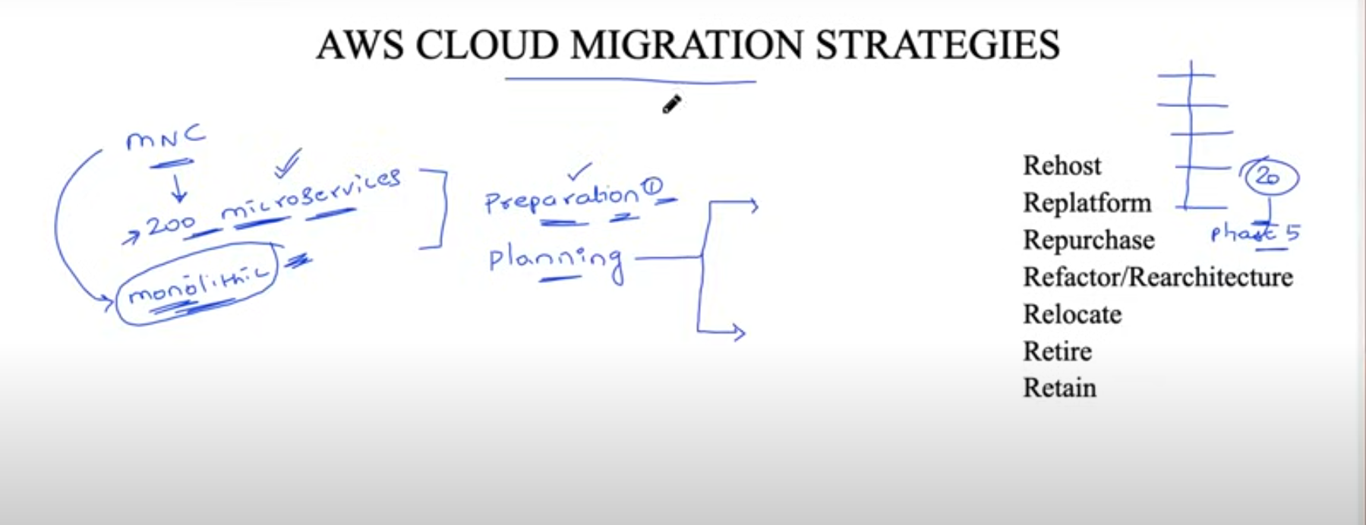

First we need to strt with

* 1)preparation

If we are having microservices then we have can proceed with planning stage if we are having only monolithic service then we need to convert monolithic to micro service along with planning

* Then during planning stage we split microservices into different phases based on criticality
* If criticality is high then we keep it in last stage if criticality level of application is less then we put it on first stage
* 2)Planning is divided in to two parts i.e,

a)Phases

b)Which cloud migration strategy you need to use among 7R’s

* Rehost: Lift and shift (you will directly transfer from on premise to aws cloud
* 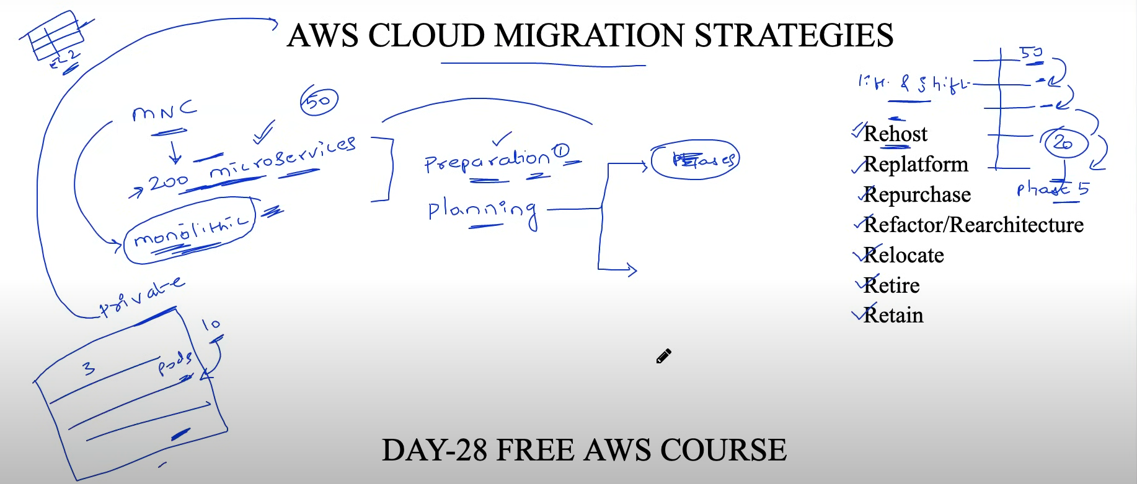
* **Rehost** :In lift and shift it will be exactly same as its in onprem and it works exactly same if there is no dependency in operating system , environment,hardware.
* Replatform : Certainly! A replatforming migration strategy involves moving an application to the cloud with minimal changes to its architecture, essentially shifting it to a more efficient infrastructure without major code modifications.
* 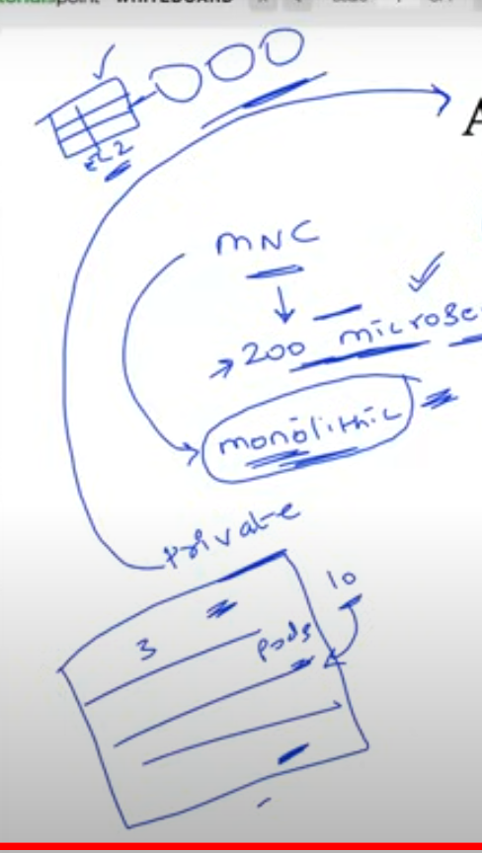
* Refactor/Rearchitecture: the best suitable example for rearchitecture is monolithic application which needs to be converted to microservices needs to rearchitecture based on latest and best suitable methods
* Relocate
* Retain
* Retire
* Repurchase
* Rehost , Replatform, Refactor/ Rearchitecture are mostly used migrating strategies in the market
* 3) migration : migrating the applications according to their phases based on criticality
* 4) monitoring: after migrating you need to monitor the applications you can create the dashboards to show the customers how well the applications are performing after migration
* 5) To improve/Optimize:
* 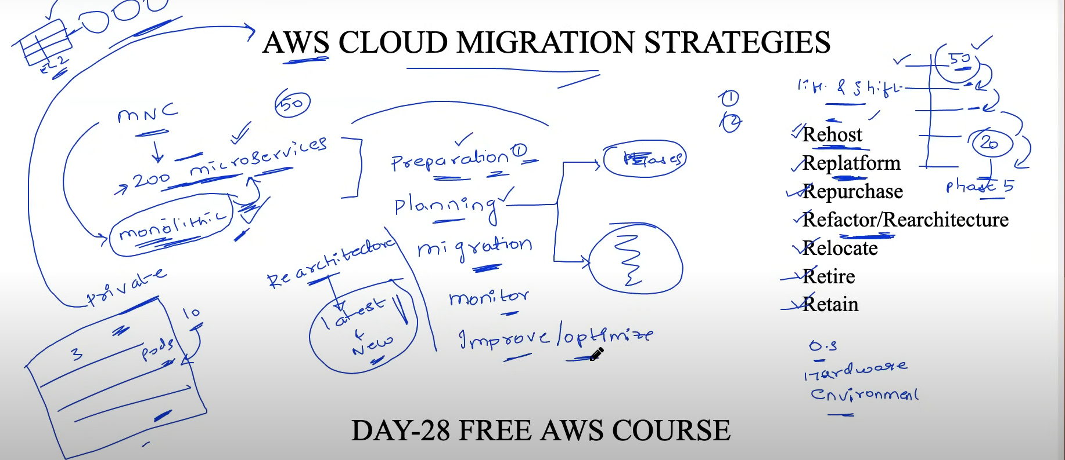
* 7r’s comes under preparation and planning stage
* 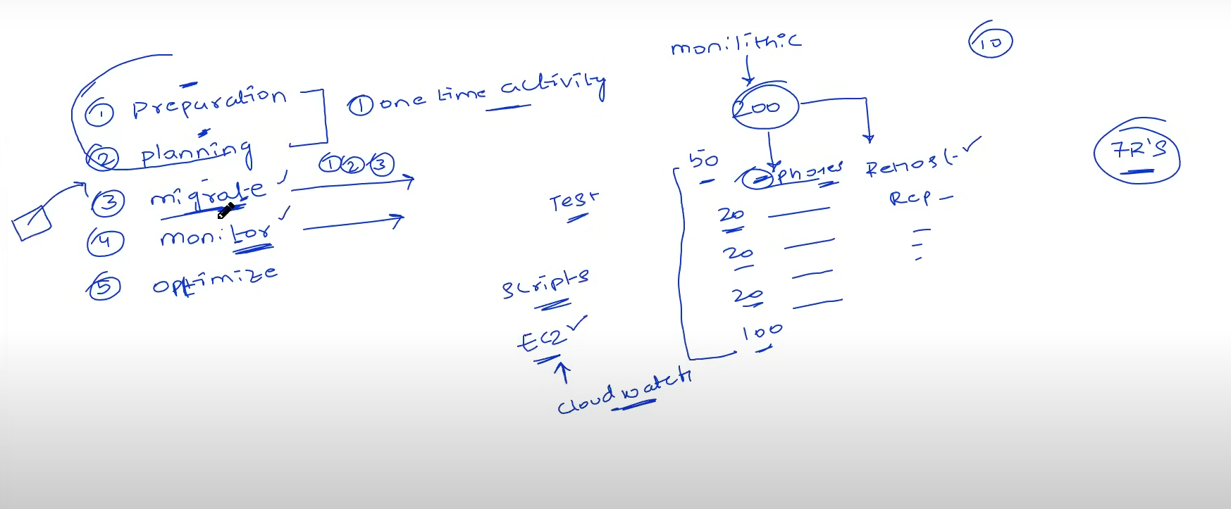
* Preparation & planning is only 1 time activity but migration phase will be done in multiple times
* In migration and monitor phase basically you will write some scripts to create infrastructure and also devops team gives us some test cases to run the tests will run the cron jobs
* Optimize is one time activity : in optimization you basically evaluate and find out what you have achieved if suppose you have saved 40% of cost will that be optimized 50% will see this kind of things in this stage
* 